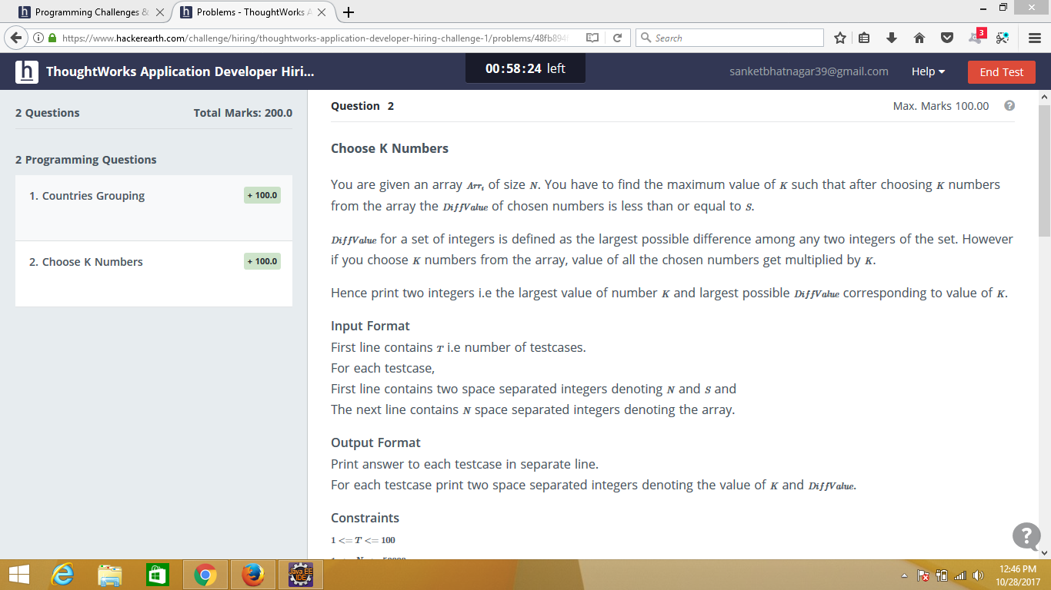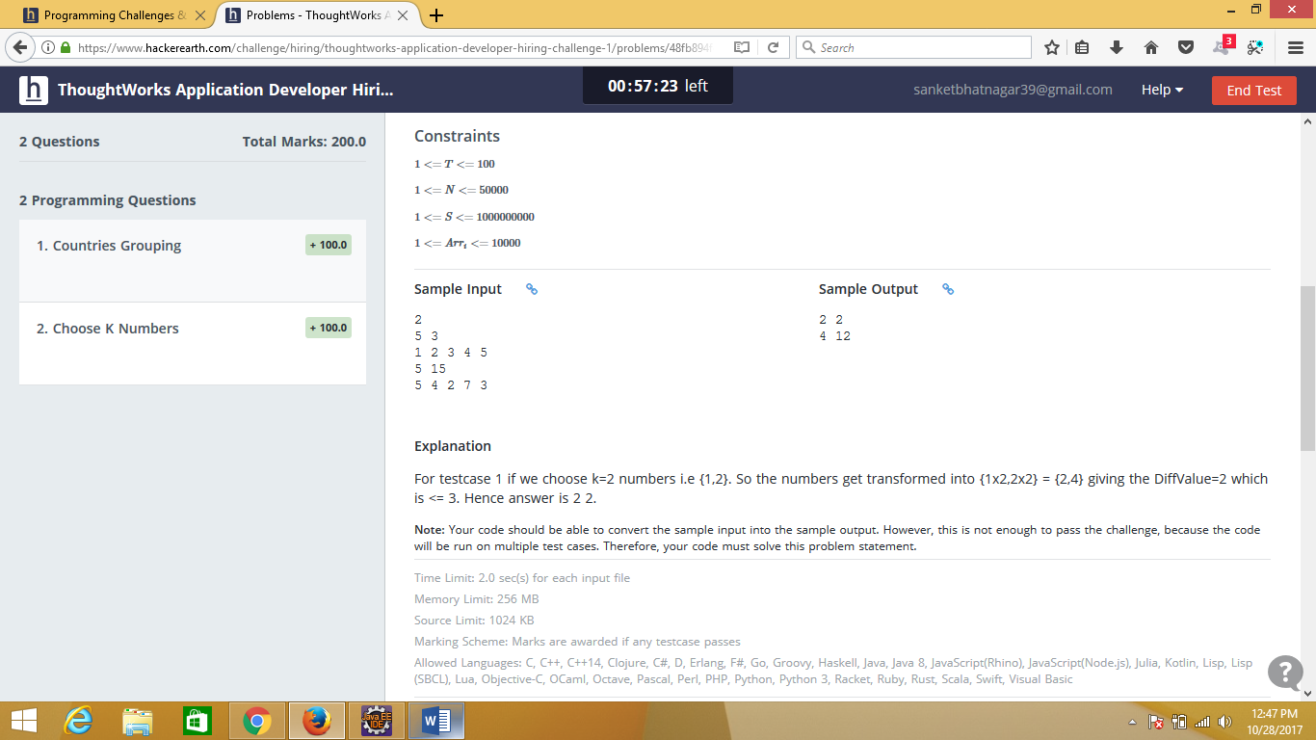

Sample input

2

5 3

1 2 3 4 5

5 15

5 4 2 7 3